

Product Change Notification

PCN Date: | July 6, 2016
Supplier Name: | Pulse Electronics
Pulse PCN No. | 16-034 REV. A
Description of Change | - Move the backend process including pin correction, testing, marking, co-planarity inspection and packaging from contract manufacturer into Pulse own factory;  - Change the ink marking to automatic laser marking;
Reason for Change | Move backend manufacturing to Pulse production for quality improvement and higher productivity.
Summary of Changes between the new and old part | Present | New
Summary of Changes between the new and old part | Backend process at contract manufacturers | Backend process at Pulse own factory which locate at Chang An, Dongguan City, Guangdong, China
Summary of Changes between the new and old part | Ink marking (example)  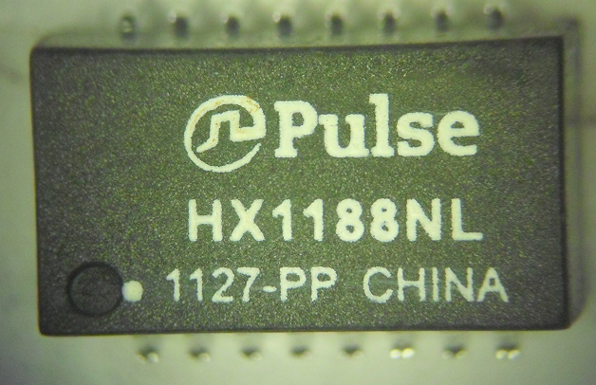 | Laser marking (example)  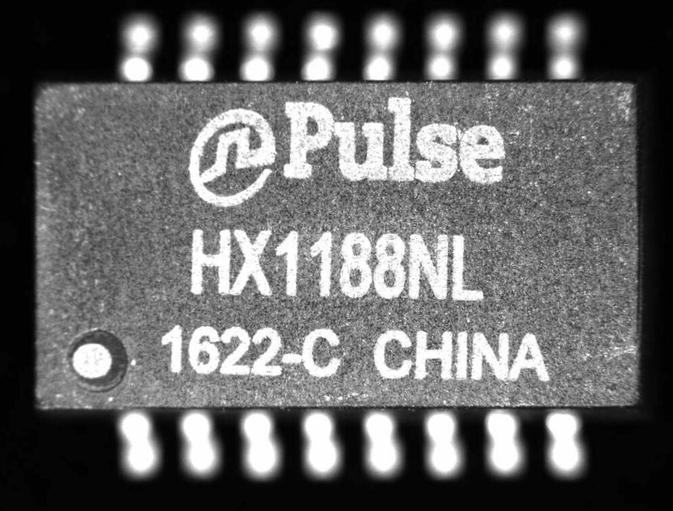
Traceability guidelines | Date code suffix change to –C, for example 1622-C
Qualification Data attached?  File name(s) | 168 hours qualification report can be available in week 36
Customer Part Number | Pulse Part Number |  | PCN Effectively Date
 | HX1188NLT |  | 10/5/2016
 | HX1188NL |  | 10/5/2016
 | H1102NLT |  | 10/5/2016
 | H1102NL |  | 10/5/2016
 | HX1188FNLT |  | 10/5/2016
 | HX1188FNL |  | 10/5/2016
 | H1662NLT |  | 10/5/2016
 | H1660NLT |  | 10/5/2016
 | H1260FNLT |  | 10/5/2016
 | H1260FNL |  | 10/5/2016
 | HX2019FNLT |  | 10/5/2016
 | HX2019FNL |  | 10/5/2016
 | HX2029NLT |  | 10/5/2016
 | H1260NLT |  | 10/5/2016
 | H1260NL |  | 10/5/2016
 | HX1198FNLT |  | 10/5/2016
 | HX1198FNL |  | 10/5/2016
 | H2019FNL |  | 10/5/2016
 | H2019FNLT |  | 10/5/2016
 | HX1260FNLT |  | 10/5/2016
 | HX1260FNL |  | 10/5/2016
 | H2019NL |  | 10/5/2016
 | H2019NLT |  | 10/5/2016
 | HX1198NL |  | 10/5/2016
 | HX1198NLT |  | 10/5/2016
 | HX2019NL |  | 10/5/2016
 | HX2019NLT |  | 10/5/2016

Customer: Avnet
Originator: Jose Xu
Phone: +86 769 85538871-4200 E-mail: JoseXu@pulseelectronics.com

