

Product Change Notification

PCN Date: |  | June 01, 2016
Supplier Name: |  | Pulse Electronics
Pulse PCN No. |  | 16-038
Description of Change |  | Change from Ink marking to Laser marking. No impact to form, fit and function.
Reason for Change |  | Process standardization
Summary of Changes between the new and old part |  | Present ink marking (example) |  |  | New laser marking (example)
 |  | 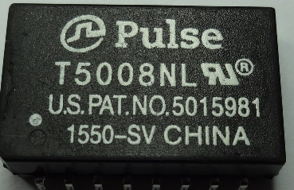  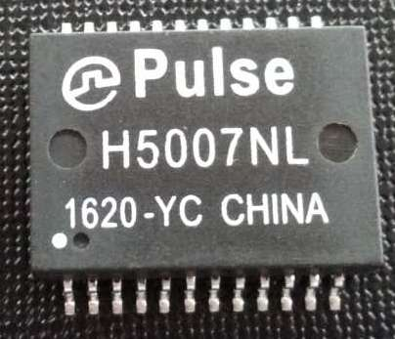 |  |  | 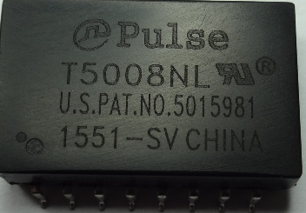  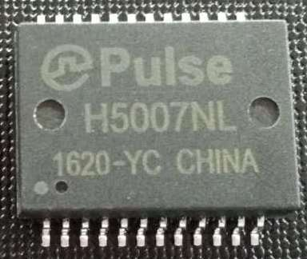
Traceability guidelines |  | Effective date: 8/01/2016
Datasheet attached? |  | No change to product datasheet
Qualification Data attached? |  | Not applicable
Customer Part Number | Pulse Part Number |  | PCN target Effectively Date | Sample availability |  | Pulse Qualification
 |  |  | 8/01/2016 | Not applicable |  | Not applicable, no change

Customer: all worldwide customers
Originator: Jose Xu
Phone: +86 769 85538871 - 4200
E-mail: JoseXu@pulseelectronics.com

