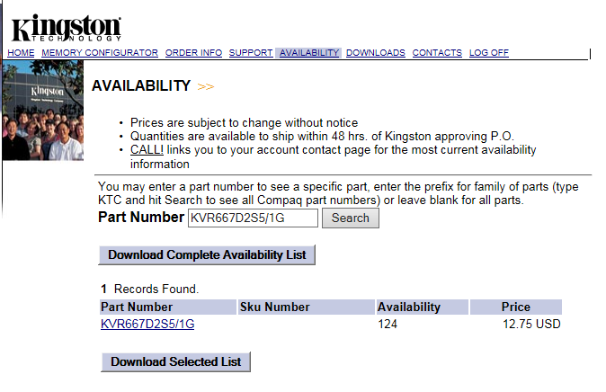

Per Sherri Zimlaw at Kingston the KVR667D2S5/1G is no longer EOL. Can we remove the EOL flag on this part in the Sap system?

